We Need Your Help! Scan Your Receipts For Box Tops!
The Box Tops for Education program has changed the way we can earn cash for our school! Have you noticed that most participating brands have changed their packaging from the traditional Box Tops clip to the new Box Tops label?

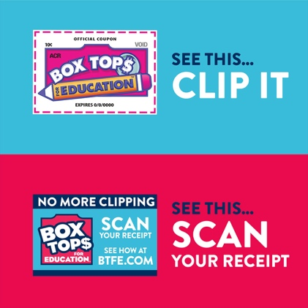
Scan Receipts for the Labels
Clip the Clips!
Instead of clipping from packages and checking expiration dates, all Box Tops will be earned digitally by scanning your receipt. This has to be done within 14 days of purchase. The Box Tops for Education team has worked hard to build a NEW-and-improved, user-friendly Box Tops mobile app, available now. Please download the new app ASAP!! Shopping online? You can still get credit. www.BTFE.com tells you how.
The new app features state-of-the-art technology that allows you to scan your store receipt, find participating products and instantly add Box Tops to our school's earnings online. Please go to www.BTFE.com for more information and product lists.
If you still have traditional Box Tops clips at home, make sure to send them to school now. We will still earn cash for all clipped Box Tops until they expire. Please send only traditional clipped Box Tops, (NOT CLIPPED LABELS!!!) to school by October 27th. Here are a few guidelines when submitting Box Tops to our school. Thank You!!!
- Please check the expiration date. Expired Box Tops are not counted so please don’t send them in.
- Box Tops do not need to be trimmed perfectly. Please don’t cut inside the dotted line.
- Please send Box Tops to school on official collection sheets (printed from their website) or in increments of 50 per plastic baggie or envelope and labeled with your child’s FULL NAME AND TEACHER. Otherwise they will not be counted toward the school class contest.
- If you have fewer than 50, don’t worry, just write the amount on the baggie.
- For questions, please contact Taylor Law at TaylorLaw82@yahoo.com

